BLP MOTO

SY70（DRONE）
Assembly Manual
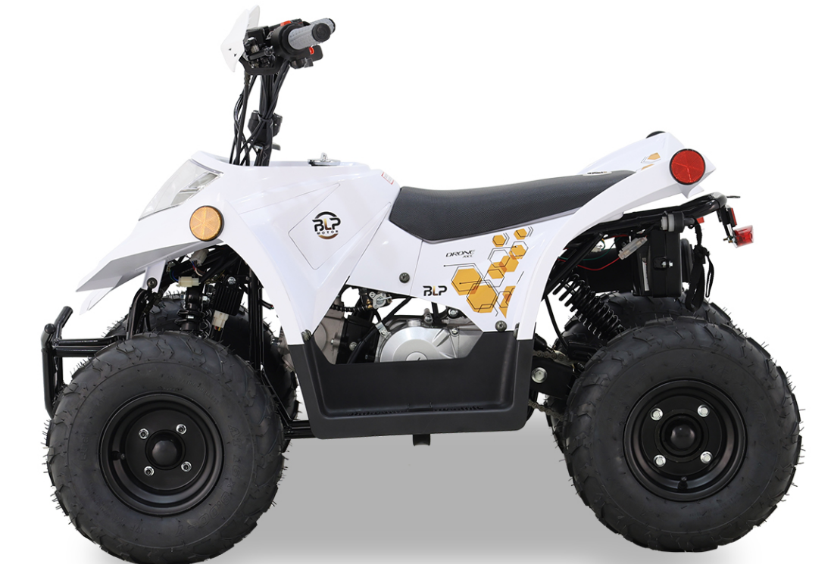

- Remove the straps and cardboard cover.
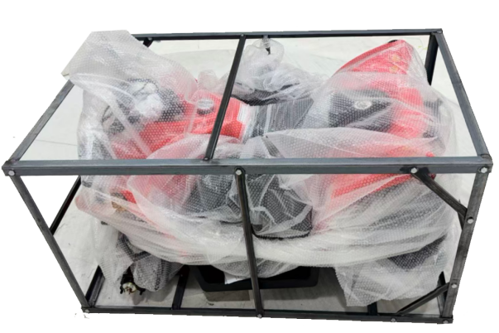
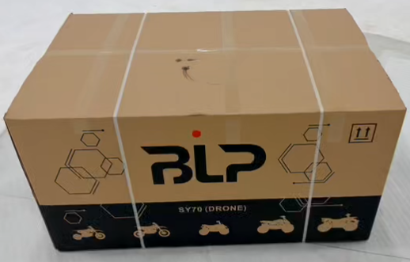
- Remove all the straps and take out the parts attached on the vehicle and the packaging iron frame, remove the iron frame screws, wait for subsequent installation.  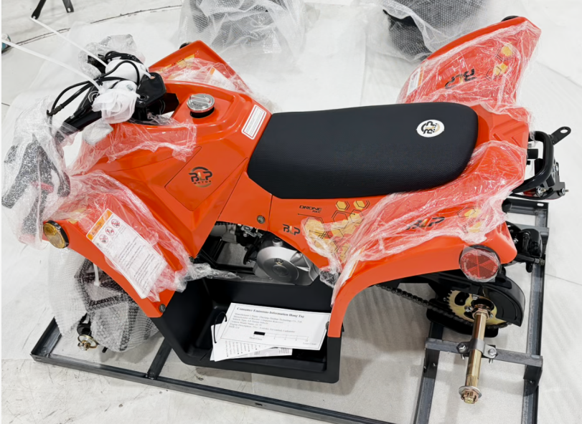 | - Make sure that all the tools in the toolbox are complete.  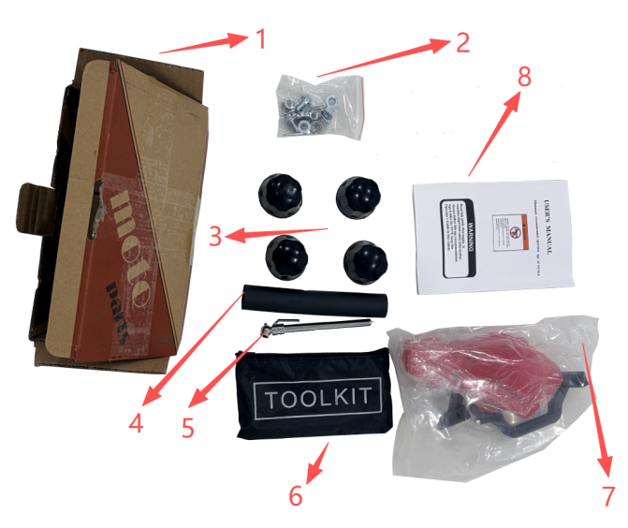  - Tool box  - Front wheel screws  - Dust cover  - Protective vest  - Tire gauge  - Tool bag  - Handguard  - User Manual
4.Open the No. 7 tool bag in Step 3  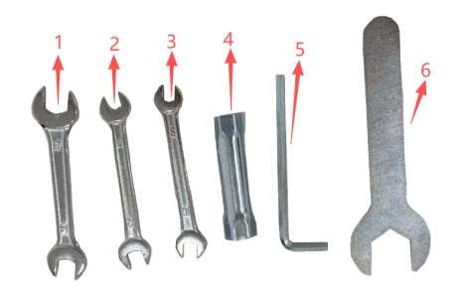  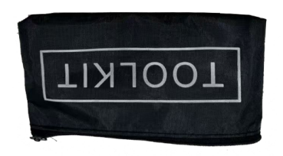  - No.14-17 wrench  - No.10-12 wrench  - No.8-10 wrench  - Spark plug sleeve  - M6 hex socket  - No.29 wrench | 5.Remove the screws from the handlebar and then install it to the bracket.  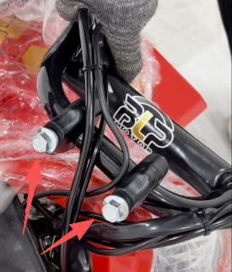  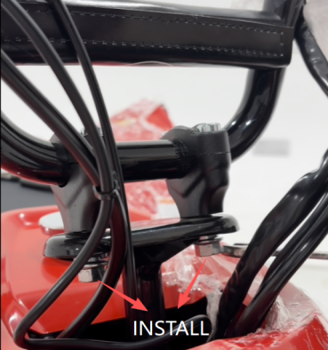
6.Use tool No.8-10 wrench to remove the screws. Place the light in the correct position, then install the screws.  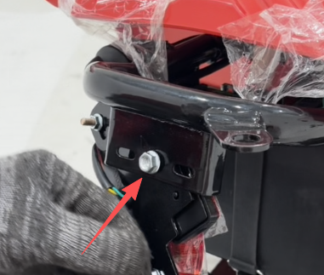  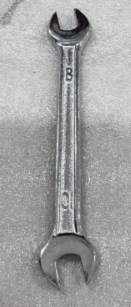  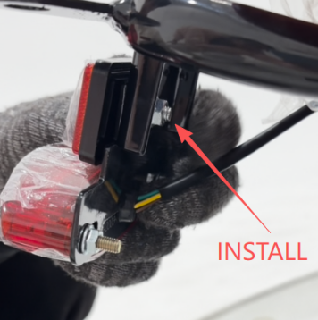  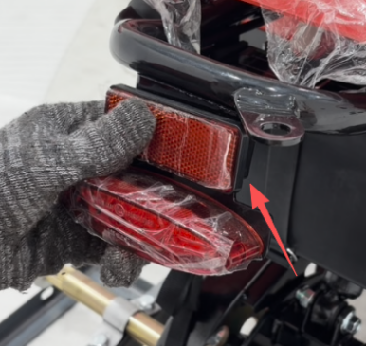 | 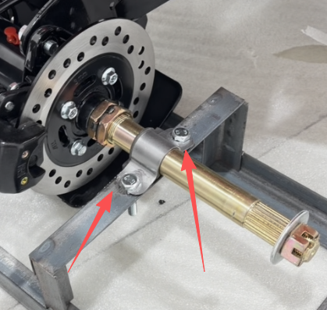  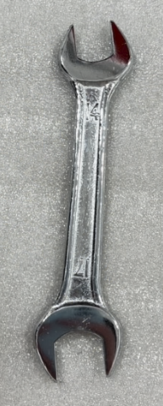  - Use tool No.14-17 wrench to remove the screws. （Both the left and right sides）
- Use tool No.29 wrench remove the nuts and washers, install the rear wheel , and then install the washers and nuts.Insert the locking pin.  The other side tire follows the same procedure.  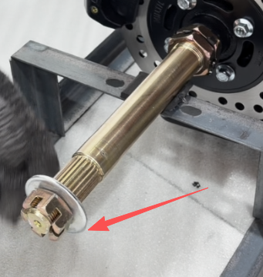  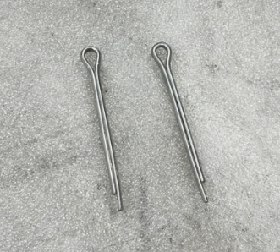  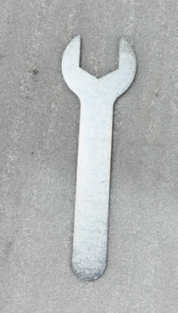  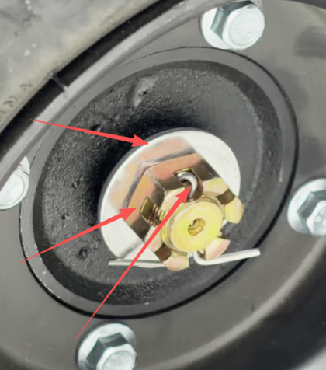 | - Use tool No.10-12 wrench and four front wheel screws(in Step3 ② Front  Wheel screws) to install the front wheel.  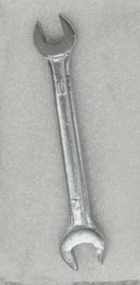  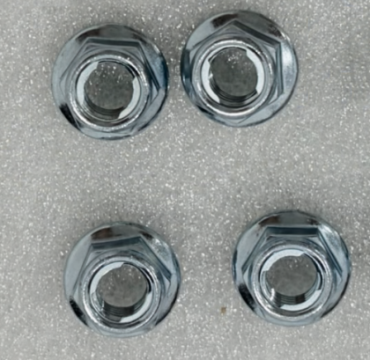  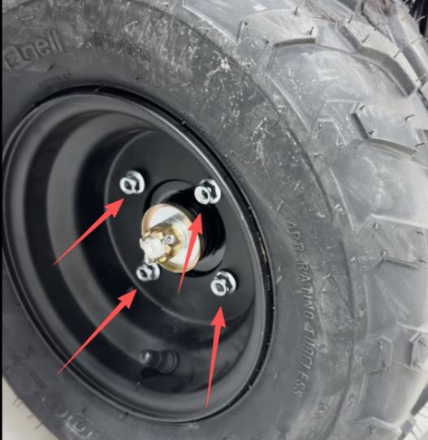
- Use tool No.14-17 wrench to install the front fork.  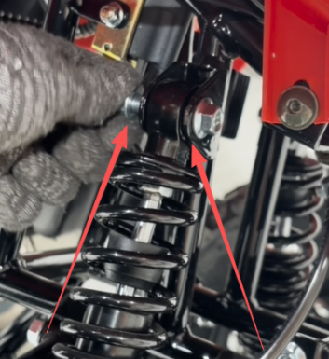 | - Use tool No.8-10 wrench remove these four screws from the frame.  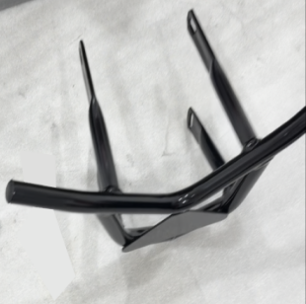  Install the front bumper and tighten the screws  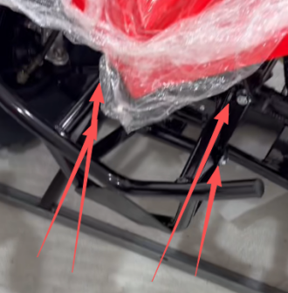  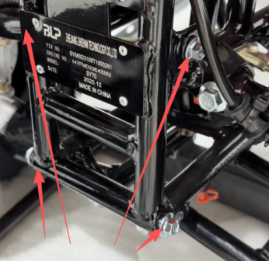
- Open ⑦handguard in Step 3.  - Insert the 1 ring onto the handle  - Install the 2 handguard bracket on the handle  - Fix the 3 guard hand onto the bracket using 4 screw and No.5 nut  - The other side tire follows the same procedure  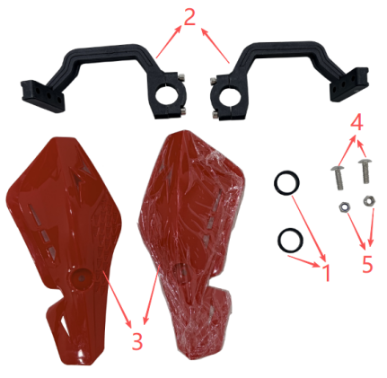  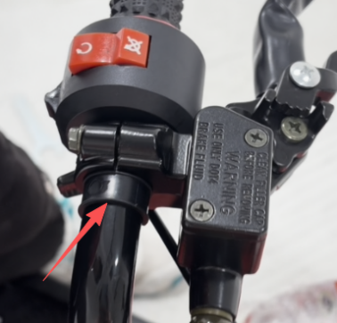  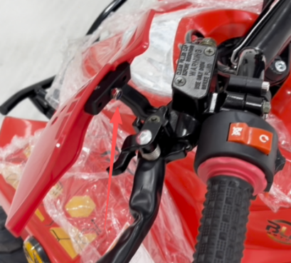  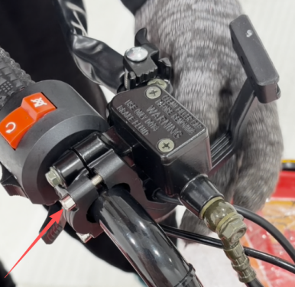 | 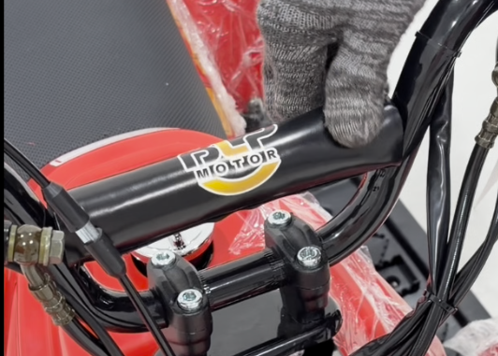  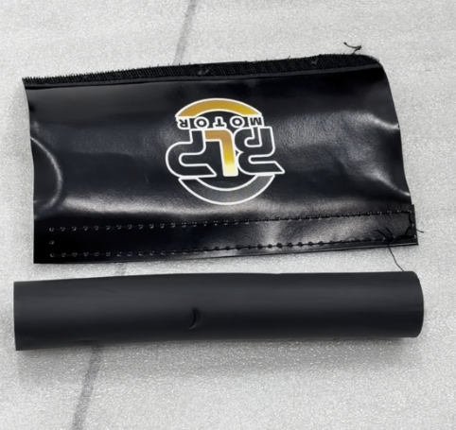  - Put on the protective sleeve and the protective leather.
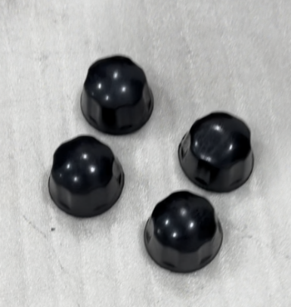  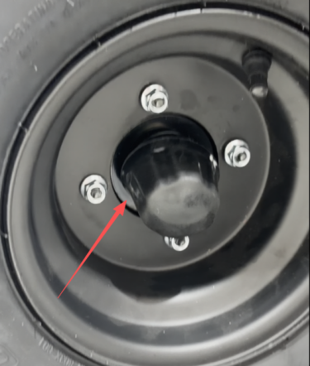  - Install the dust cover. | 