BLP MOTO

PAD140-V2(V5)
Assembly Manual
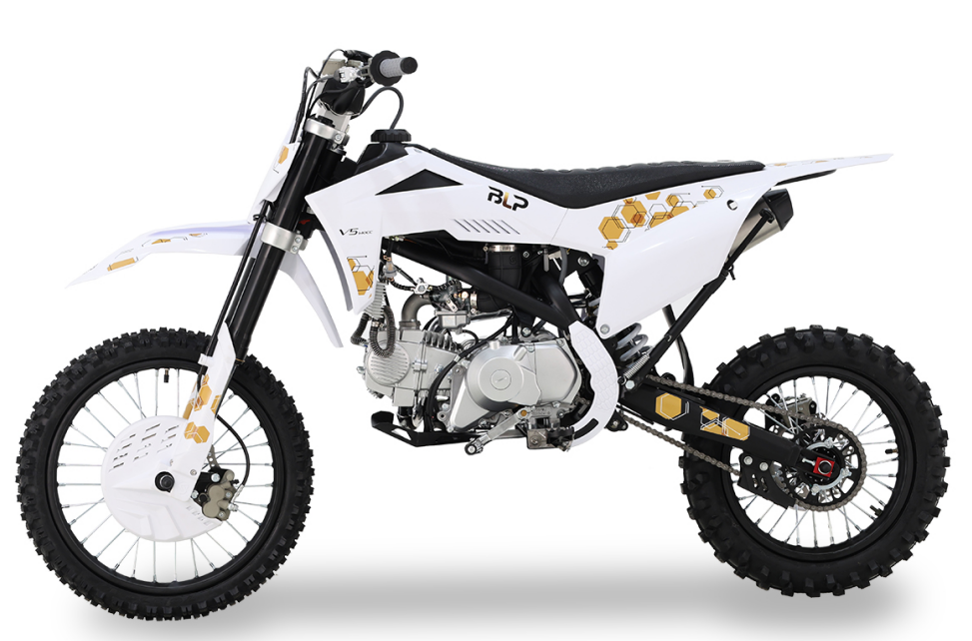

- Remove the straps and cardboard cover.

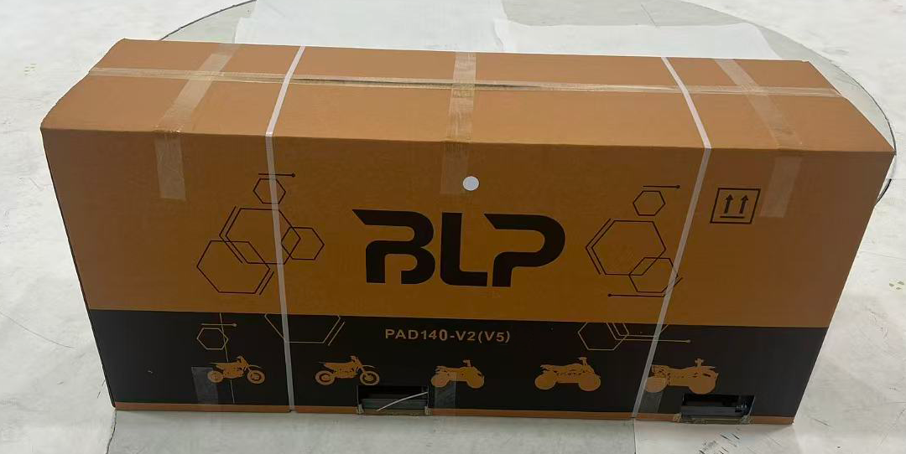
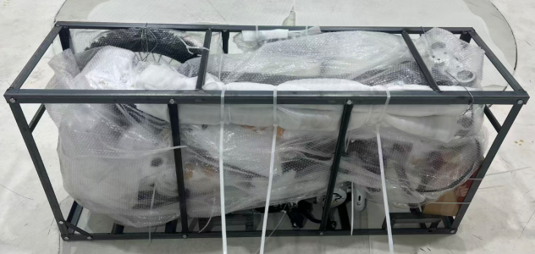

- Remove all the straps and take out the parts attached on the vehicle and the packaging iron frame, remove the iron frame screws, wait for subsequent installation.  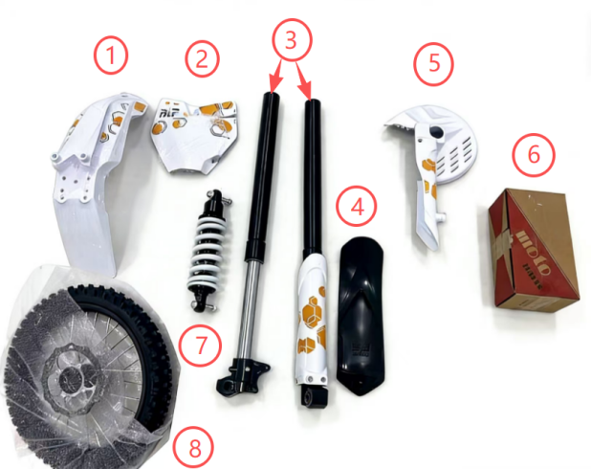  - Front fender  - Front number plate  - Front fork assembly  - Rear mud plate  - Front fork guard plate  - Tool box  - Rear shock  - Front wheel | - Make sure that all the tools in the toolbox are complete.  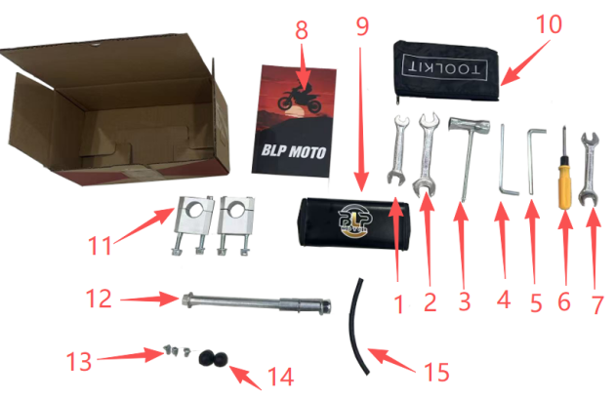  - No.13-15 wrench  - No.17-19 wrench  - Spark plug box wrench  - 6mm hexagon socket  - 5mm hexagon socket  - Screwdriver  - No.14-17 wrench  - User manner  - Square-shaped protective vest  - Tool bag  - Upper and lower clamp  - Front wheel axle  - Self-tapping screw  - Front wheel axle sleeve  - Oil pipe
4.Use tool No.14-17 wrench and 6mm hexagon socket to install the handlebar.  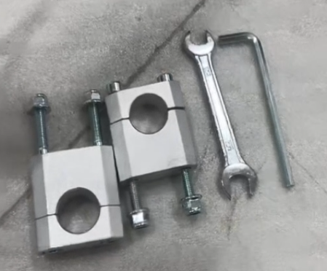  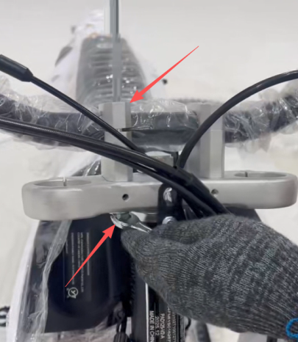 | 5.Installed the clutch cable.  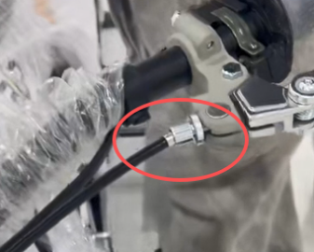  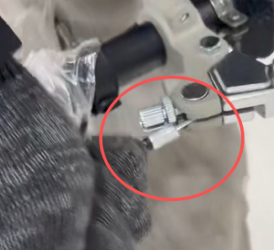  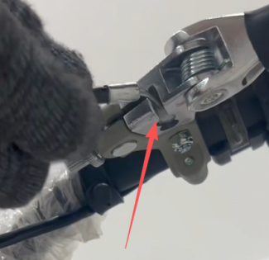
6.Use tool No.13-15 wrench to install the rear shock.  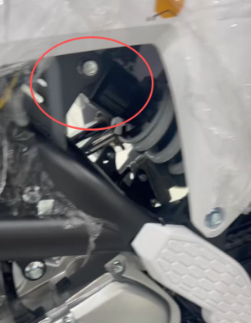  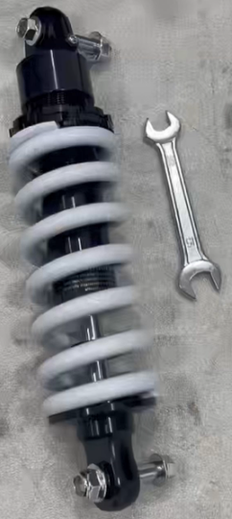  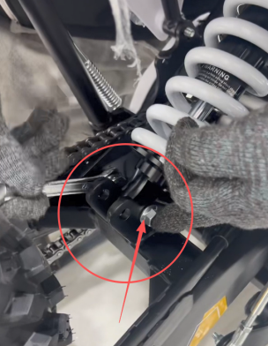 | - Use tool 6mm and 5mm hexagon socket to install front fork assembly.  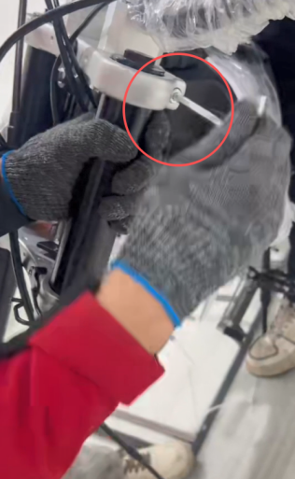  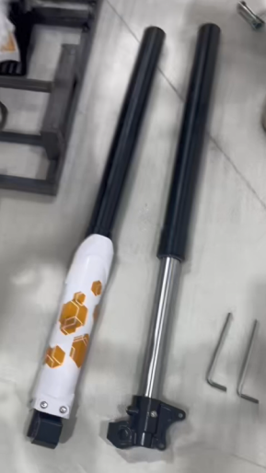
- Use tool No.14-17 wrench and No.17-19 wrench to install the front wheel (bushings are long on the left and short on the right, flange shaft enters from the left)  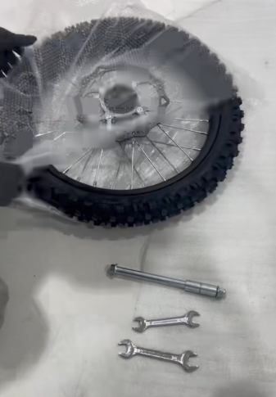  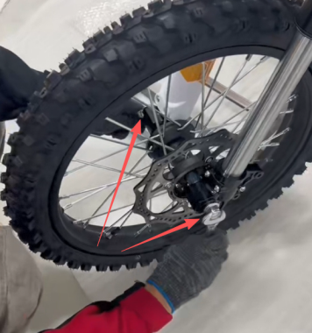 | - Remove the fixing bolt of the caliper of the front brake, and remove the plastic buckle,and install the front brake.  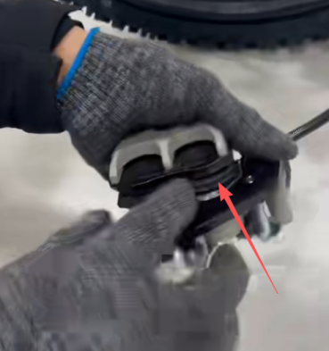  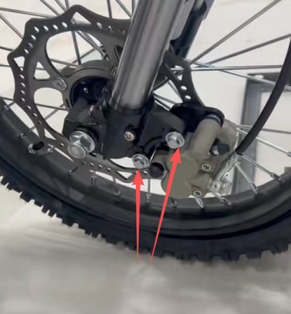
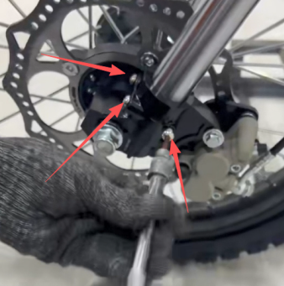  10.Loosen the screws of the front guard plate, install the front guard plate, and install the front wheel axle guard sleeve.  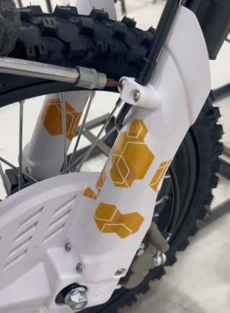  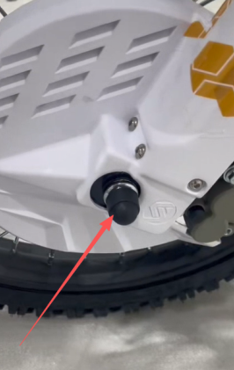 | 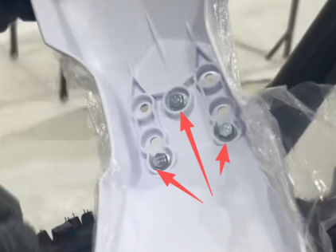  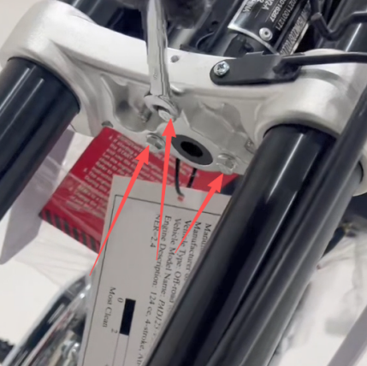  11.Install the front fender
12.Install the front number plate  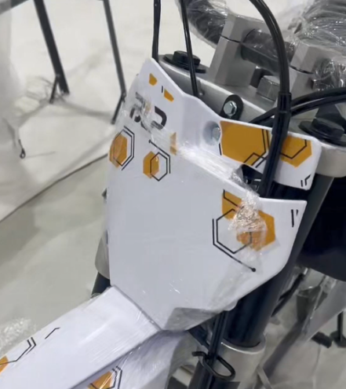  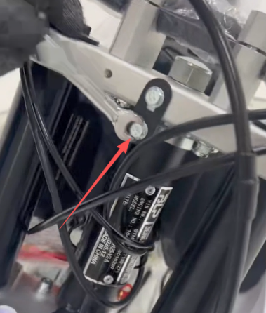 | 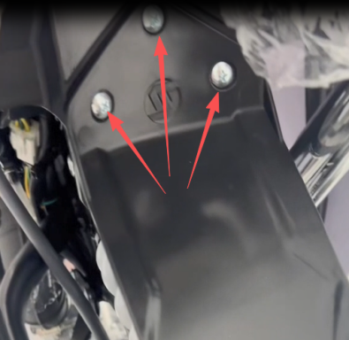  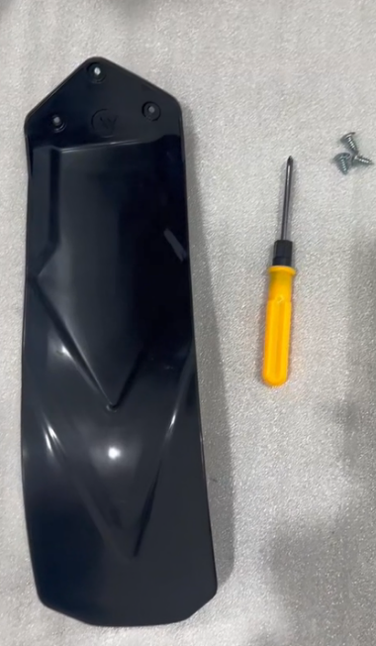  - Install the rear mud plate

