BLP MOTO

PAD90-V2(V1)
Assembly Manual
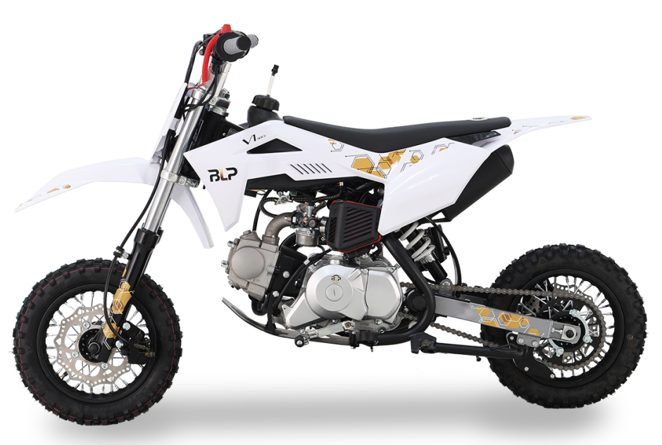

- Remove the straps and cardboard cover.
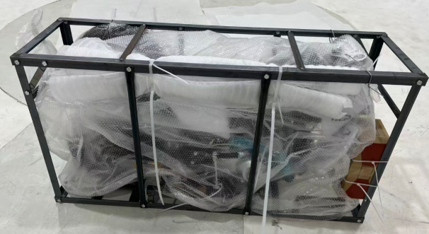
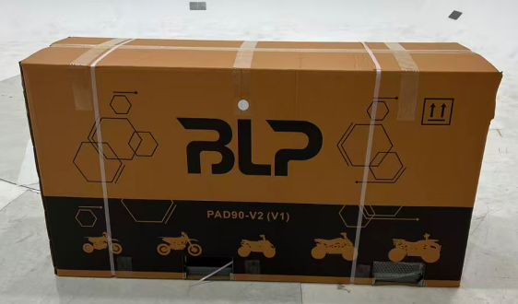
- Remove all the straps and take out the parts attached on the vehicle and the packaging iron frame, remove the iron frame screws, wait for subsequent installation.  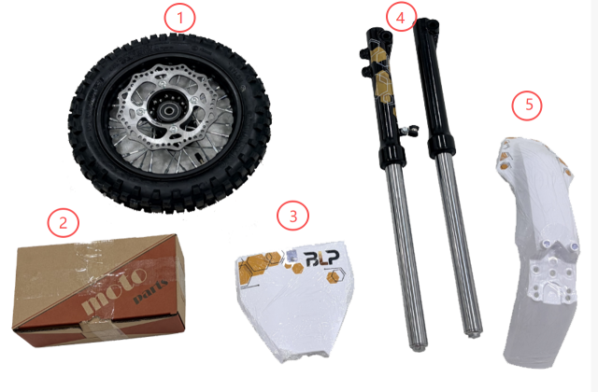  - Front wheel  - Tool box  - Front number plate  - Front fork assembly  - Front fender | - Make sure that all the tools in the toolbox are complete.  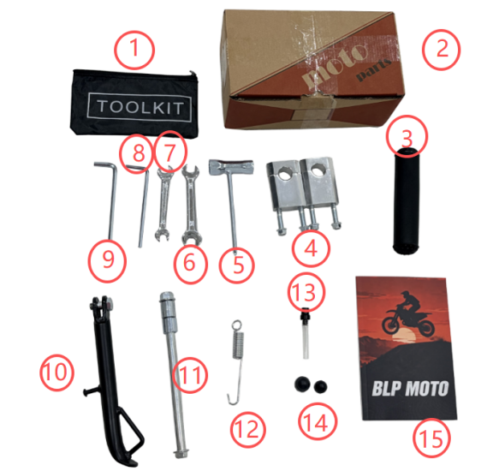  - Tool bag  - Tool box  - Protective vest  - Upper and lower clamp  - Spark plug box wrench  - No.12-14 wrench  - No.10-12 wrench  - 6mm hexagon socket  - 5mm hexagon socket  - Single support  - Front wheel axle  - Single support spring  - Bidirectional ventilation valve  - Front wheel axle sleeve  - User manner

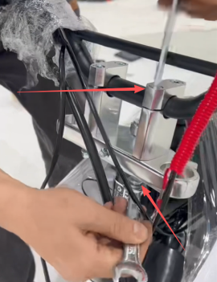  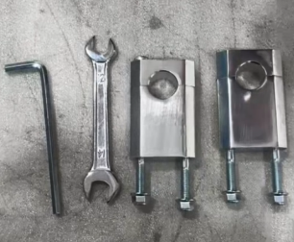  4.Use tool No.10-12 wrench and 6mm hexagon socket to install the handlebar. | 5.Use tool 6mm hexagon socket to install front fork assembly.  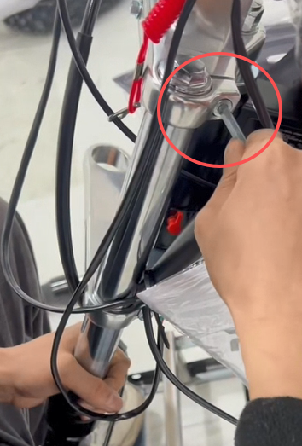  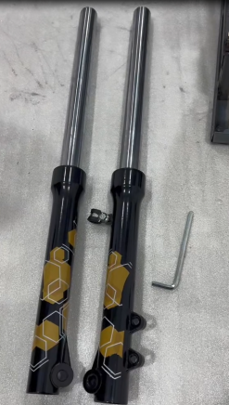
- Use tool No.12-14 wrench and No.14-17 wrench to install the front wheel (bushings are long on the left and short on the right, flange shaft enters from the left)  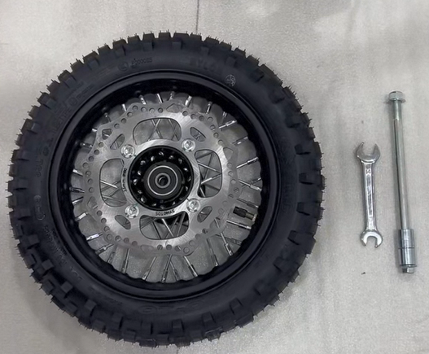  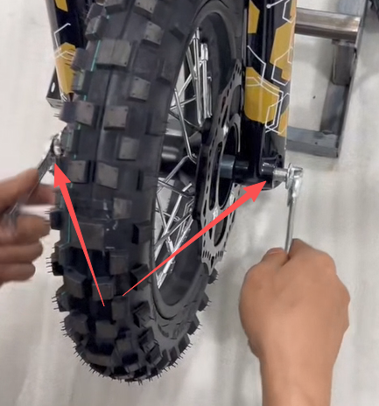 | - Remove the fixing bolt of the caliper of the front brake, and remove the plastic buckle,and install the front brake.  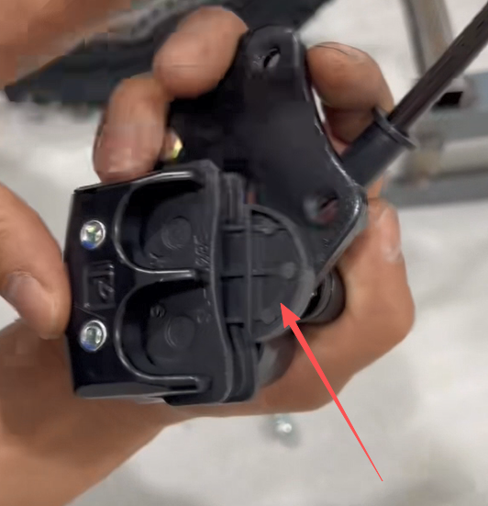  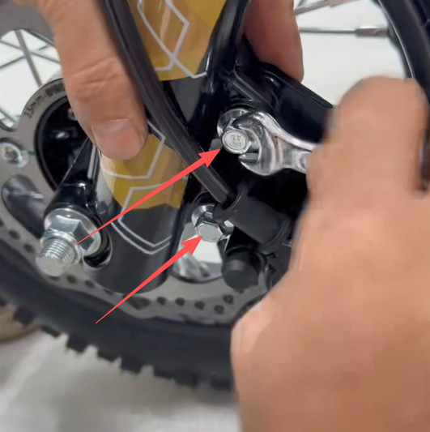

- Loosen the screws of the oil pipe clamp, and install the front wheel axle guard sleeve.  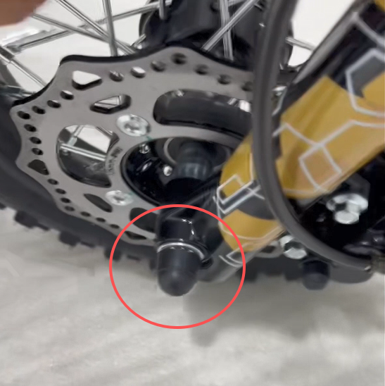  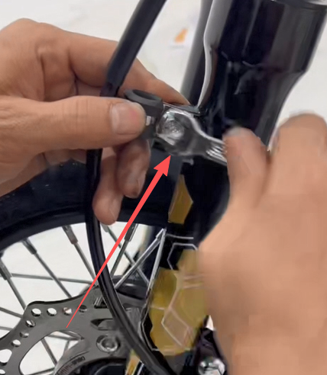 | 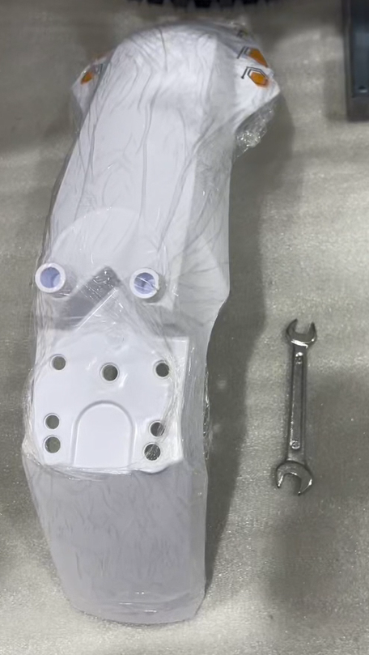  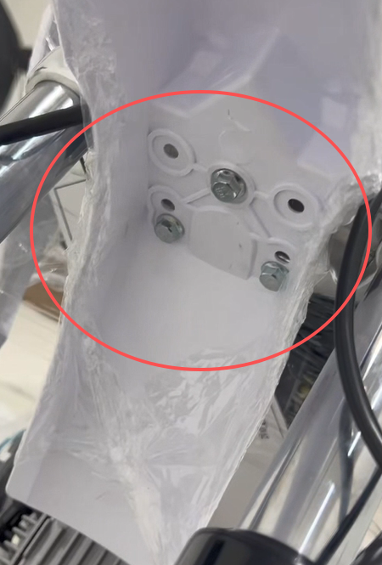  9.Install the front fender
10. Install the front number plate.  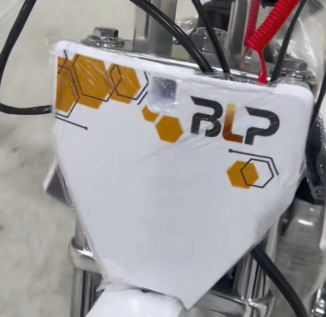  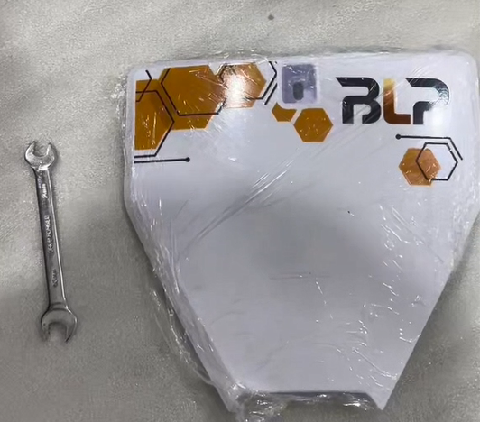 | 11.Install the rear shock.  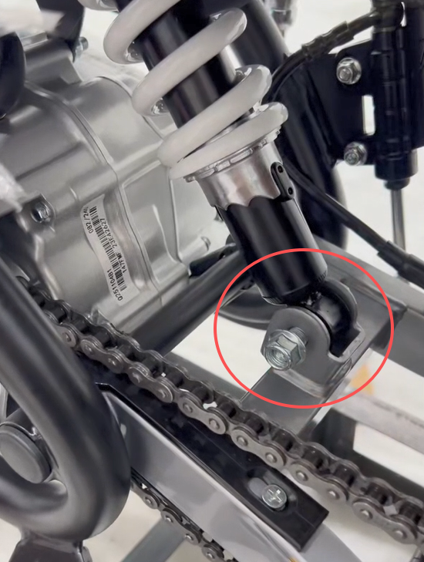
- Use tool No.17 wrench install the single support
