BLP MOTO

SY125UT-D
Assembly Manual
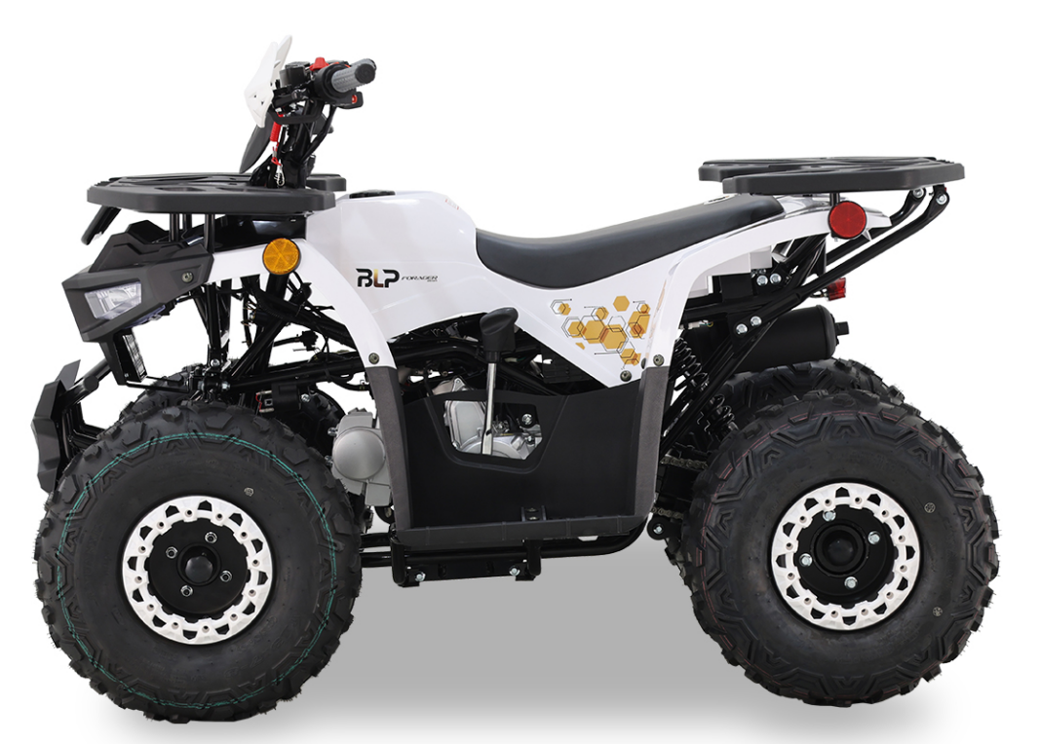

- Remove the straps and cardboard cover.
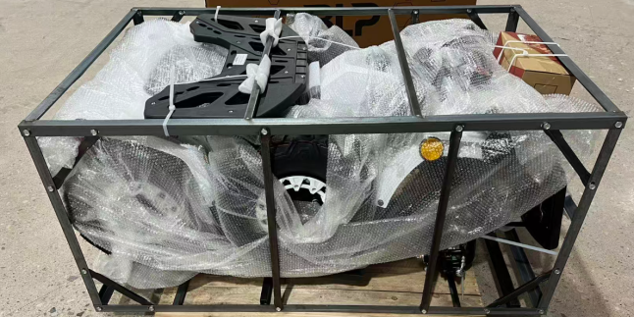
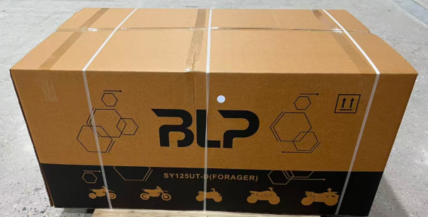
- Remove the tool box,make sure all the tools in the toolbox are complete.  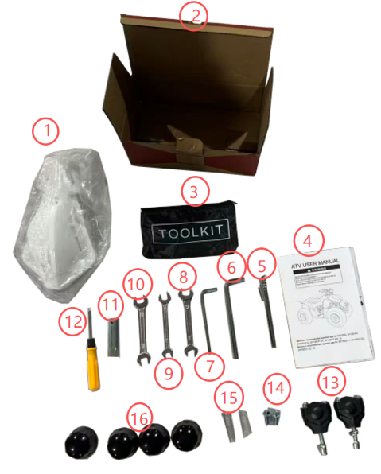  - Handguard  - Tool box  - Tool bag  - Manual  - Tire gauge  - 8mm hexagon socket  - 6mm hexagon socket  - No.12-14 wrench  - No.10-12 wrench  - No.13-15 wrench  - Spark plug box wrench  - Screwdriver  - Upper and lower clamp  - The screw of the bumper  - Cotter  - Dust cover | - Remove the iron frame screws and take out iron frame, take out the parts attached on the vehicle.  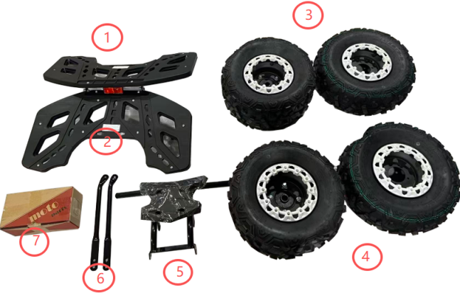  - Front shelf  - Rear shelf  - Rear wheel  - Front wheel  - Front bumper  - Rear shelf bracket  - Tool box

- Use tool No.10-12 and No.14-12 wrench to remove the iron frame.  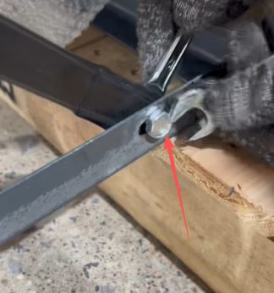  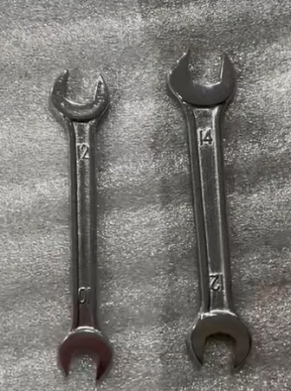 | - Install the speedometer and handlebar with tool 8mm and 6mm hexagon socket.  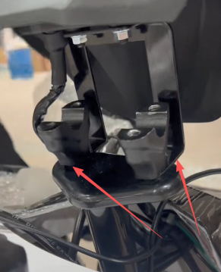  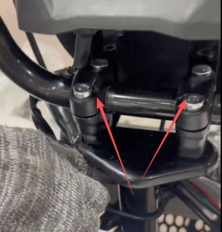  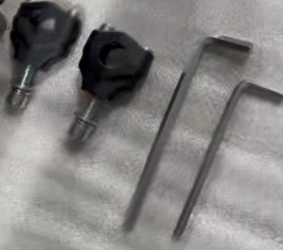
- Install the front & rear brake upper pump.  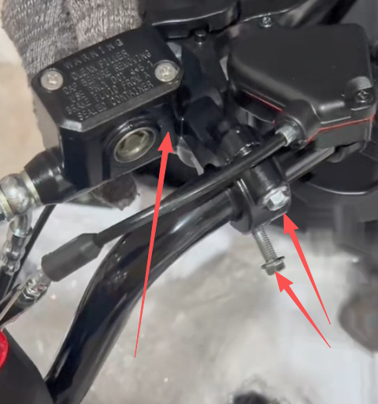  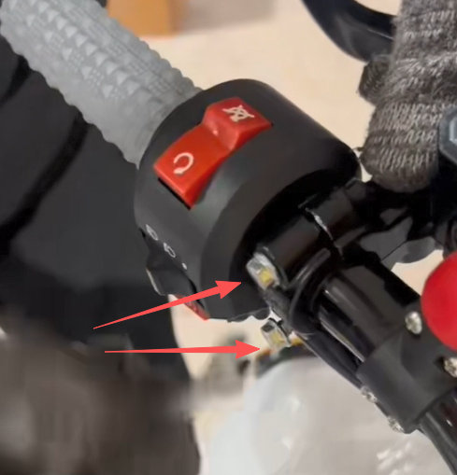 | - Install the front shelf with No.10-12 wrench.(Loosen the front shelf fixing bolts,and align with the holes on the shelf and tighten the fixing screws.)  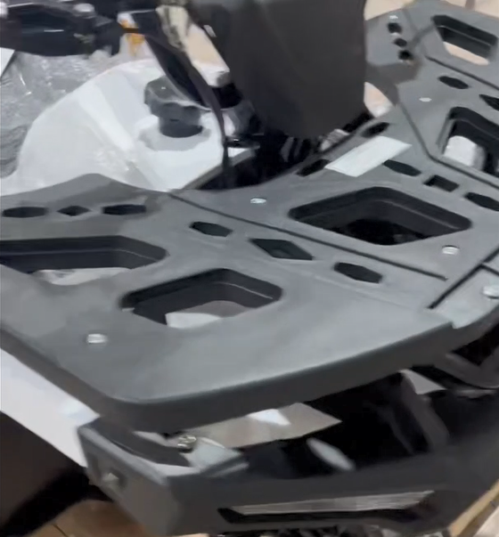  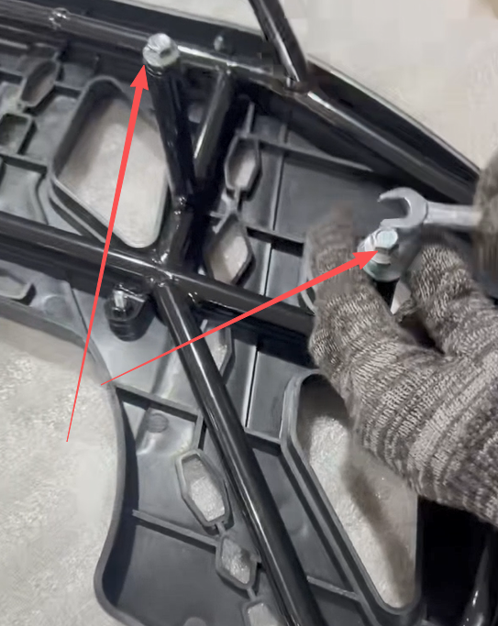  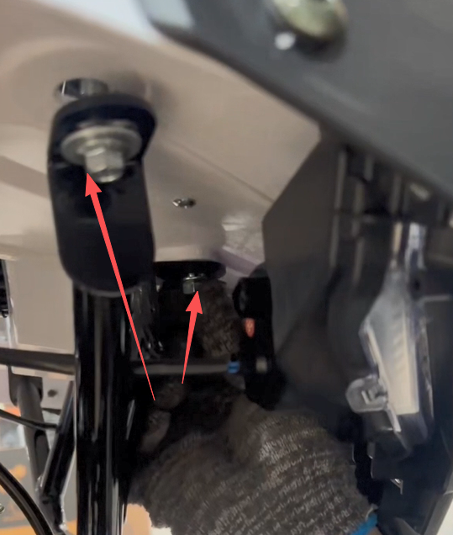

- Install the rear shelf with No.10-12 & No.13-15 wrench.(Loosen the fixing bolts of the rear shelf and the muffler fixing bolts,install the rear shelf bracket.)  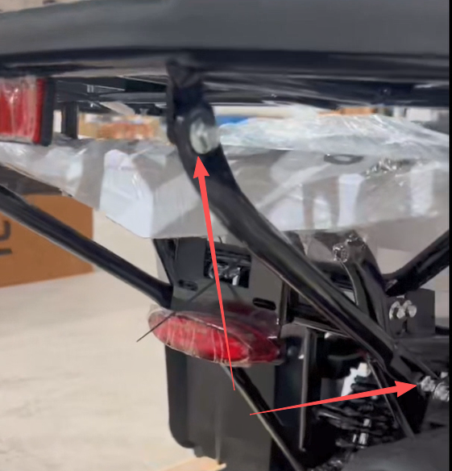  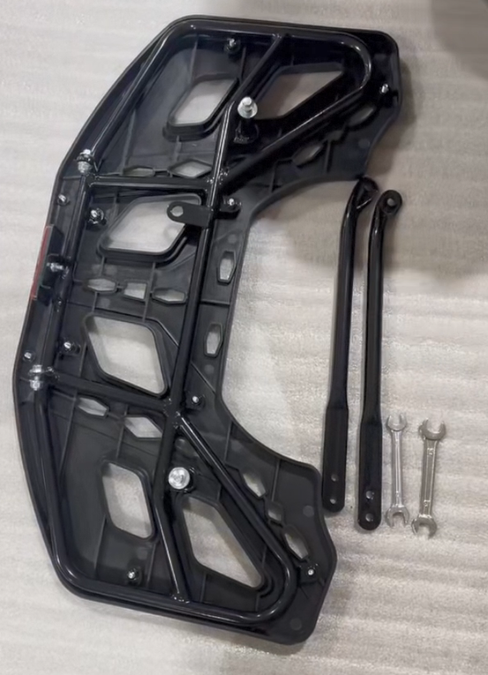 | - Remove the front bumper bolts with the No.10-12 wrench and remove the rear axle fixing bolts with the No.10-12&No.17 wrench  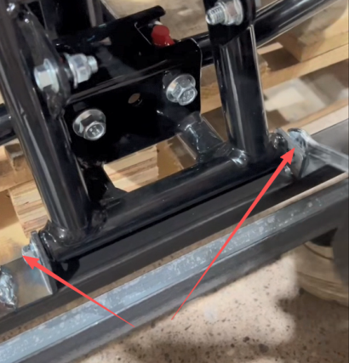  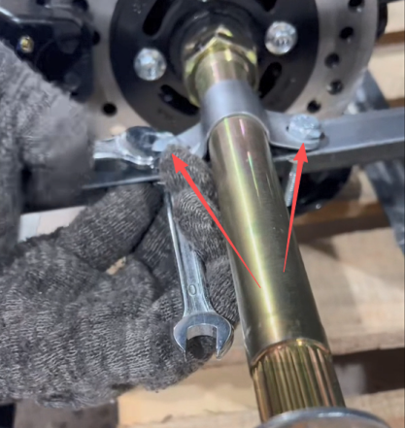
10.Install the rear shock with the No.12-14 & No.13-15 wrench.  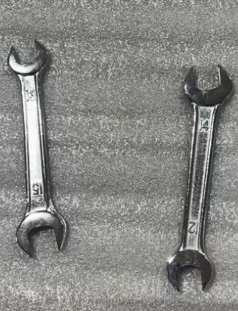  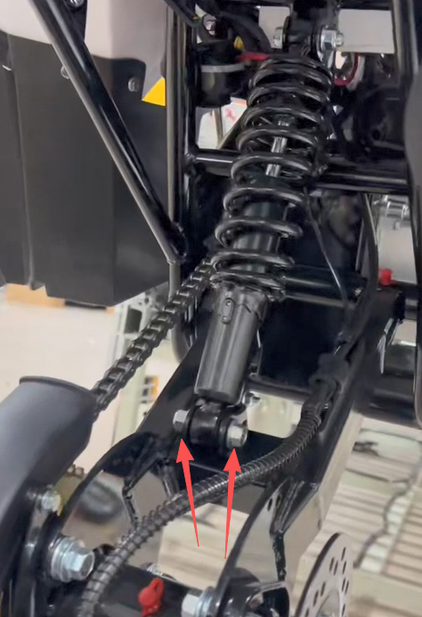 | 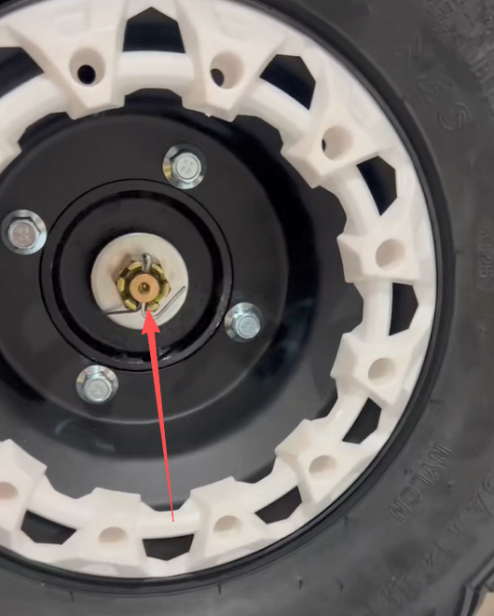  11 Install the rear wheel with the No.24 wrench.(Remove the rear axle fixing bolts and install the rear wheel ,and tighten the bolts and install the big R pin and the dust cover.)  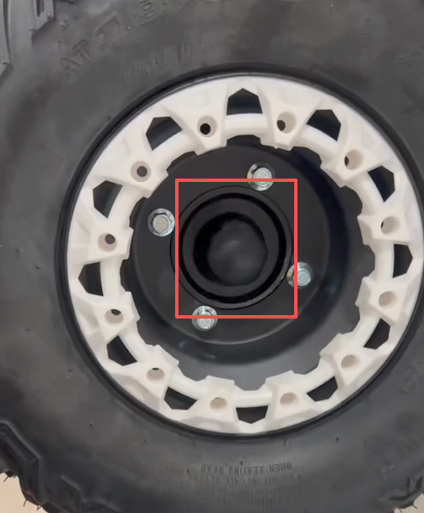
- Install the front fork with No.13-15 &No.17 wrench.  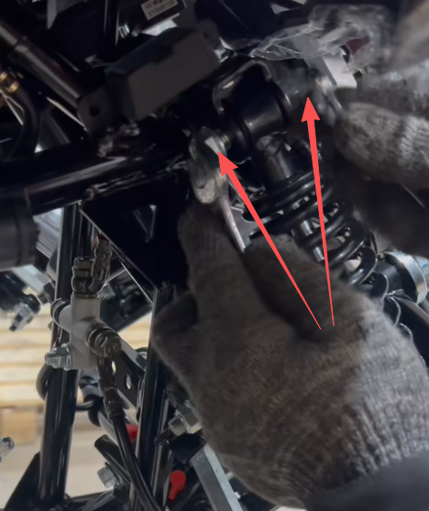 | 13.Install the front steering track rod with No.17 wrench and small R pin  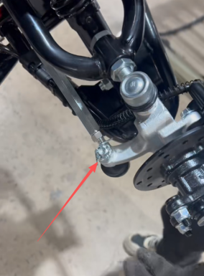  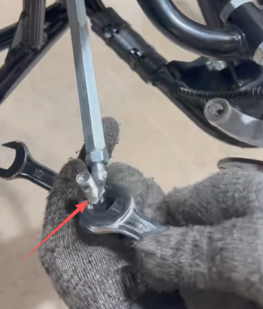
14.Install the front wheel with No.13-15 wrench.(Remove the 4 fixing bolts and install the front wheel ,and tighten the bolts,and install the dust cover.)  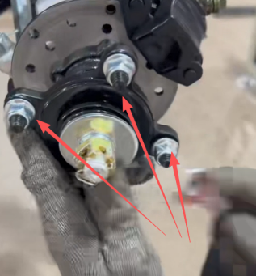  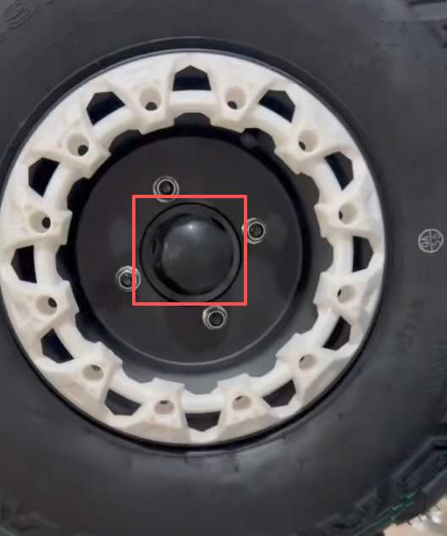  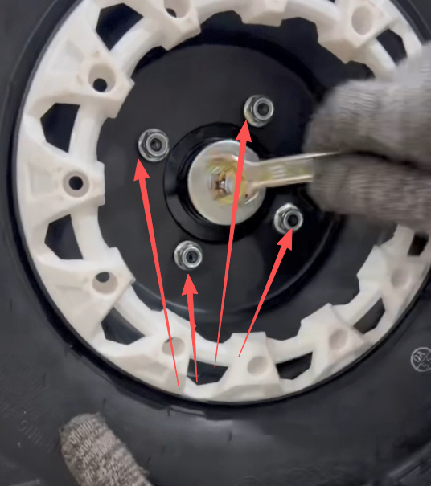 | - Install the front bumper with No.13-15 & No.10-12 wrench and 2 fixing bolts.  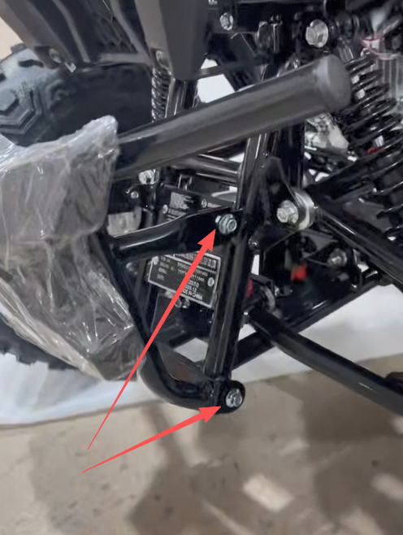  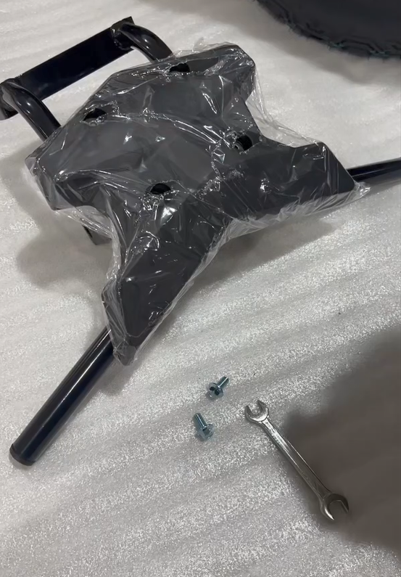
- Install the handguard.
